**Google Cloud Pub/Sub**

# **What is Google Cloud Pub/Sub?**

Google Cloud Pub/Sub brings the scalability, flexibility, and reliability of enterprise message-oriented middle ware to the cloud. By providing many-to-many, asynchronous messaging that decouples senders and receivers, it allows for secure and highly available communication between independently written applications. Google Cloud Pub/Sub delivers low-latency, durable messaging that helps developers quickly integrate systems hosted on the Google Cloud Platform and externally.

A publisher application creates and sends messages to a topic. Subscriber applications create a subscription to a topic to receive messages from it. Communication can be one-to-many (fan-out), many-to-one (fan-in), and many-to-many.

**Google Cloud Pub/Sub Configuration:**

1. Set up a Cloud Platform Console project and Enable the “Cloud Pub/Sub API” for that project
2. Install and initialize the cloud SDK and update & install beta components

Open cloud sdk on your local machine

pubsub1

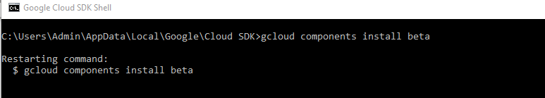

3) Go to the Google Cloud Pub/Sub topics page in the Cloud Platform Console and click on create topic. Enter a unique name for the topic

Pub sub topic creating, subscribing and Pushing messages can be done in two ways.

1. Through Cloud Pub/Sub API
2. Through Command line.

**Cloud Pub/Sub API:**

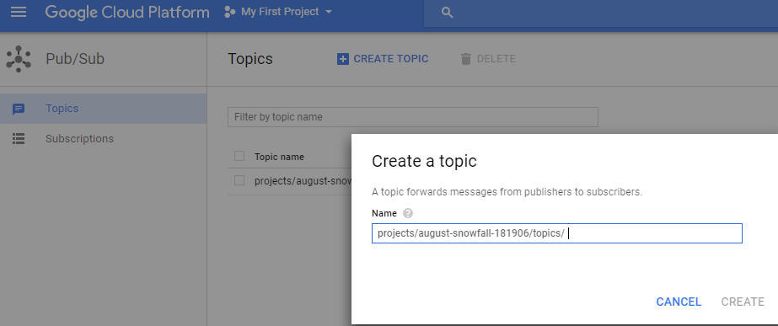

After creating topic, Goto your topic and click on 3 vertical dotted points.

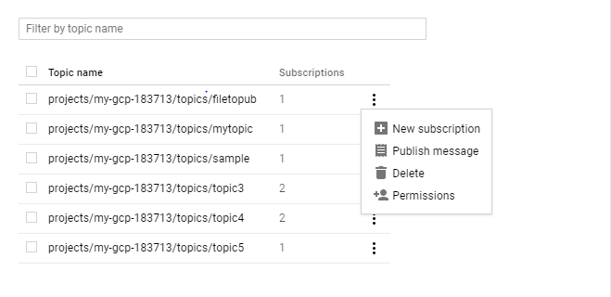

Click on new subscription and give subscription name and few options for this.

Acknowledgment deadline for subscription will be 10 to 600 sec.

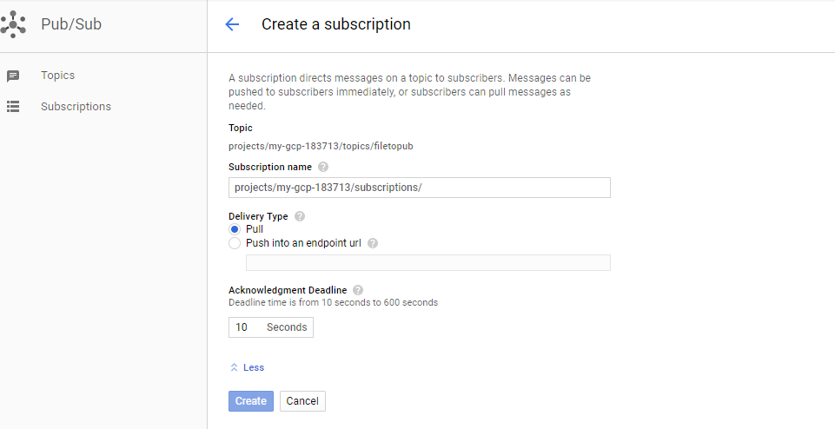

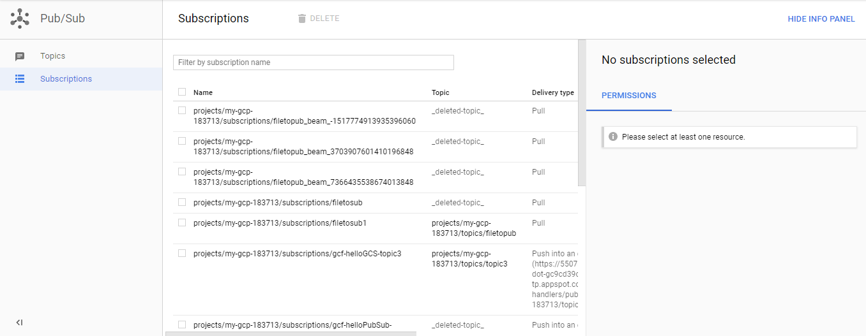

**Cloud Pub/sub command-line**

gcloud init

gcloud components install beta

gcloud beta pubsub topics create topic1 //creates topic name

gcloud beta pubsub subscriptions create --topic topic1 sub1

//creates subscription to created topic

gcloud beta pubsub topics publish topic1 "Hello" //publishes message to given topic

gcloud beta pubsub subscriptions pull --auto-ack sub1

//pulling message from subscription

There are some flags which we use to set properties.

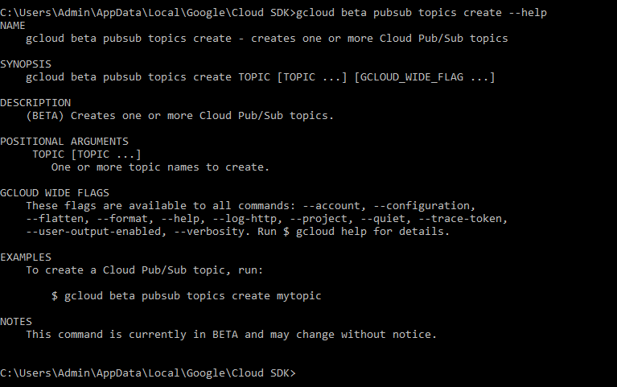

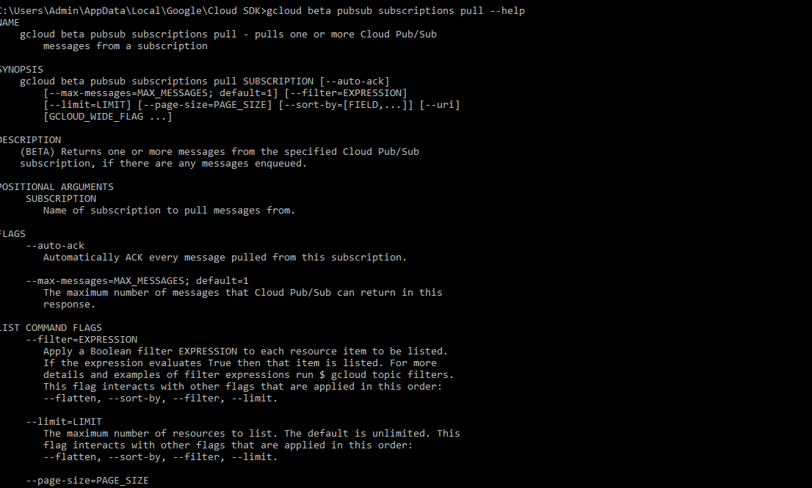

## Common scenarios

Here are some classic use cases for Google Cloud Pub/Sub:

**Balancing workloads in network clusters.** For example, a large queue of tasks can be efficiently distributed among multiple workers, such as Google Compute Engine instances.

**Implementing asynchronous workflows.** For example, an order processing application can place an order on a topic, from which it can be processed by one or more workers.

**Distributing event notifications.** For example, a service that accepts user signups can send notifications whenever a new user registers, and downstream services can subscribe to receive notifications of the event.

**Refreshing distributed caches.** For example, an application can publish invalidation events to update the IDs of objects that have changed.

**Logging to multiple systems.** For example, a Google Compute Engine instance can write logs to the monitoring system, to a database for later querying, and so on.

**Data streaming from various processes or devices.** For example, a residential sensor can stream data to backend servers hosted in the cloud.

**Reliability improvement.** For example, a single-zone Compute Engine service can operate in additional zones by subscribing to a common topic, to recover from failures in a zone or region.

**Benefits and feature**s

**Unified messaging:** Durability and low-latency delivery in a single product

**Global presence:** Connect services located anywhere in the world

**Flexible delivery options:** Both push- and pull-style subscriptions supported

**Data reliability:** Replicated storage and guaranteed at-least-once message delivery

**End-to-end reliability:** Explicit application-level acknowledgement

**Data security and protection:** Encryption of data on the wire and at rest

**Flow control:** Dynamic rate limiting implemented by the Pub/Sub system

**Simplicity:** Easy-to-use REST/JSON API

**Cloud functions with cloud pub/sub trigger**

This simple tutorial demonstrates writing, deploying, and triggering a Background cloud functions  with a cloud pub/sub trigger.

Objectives

Write and deploy a Background cloud function.

Trigger the function by publishing a message to a cloud pub/sub topic.

Before we begin

Select or create a Cloud Platform project.

[GO TO THE MANAGE RESOURCES PAGE](https://console.cloud.google.com/cloud-resource-manager" \t "https://cloud.google.com/functions/docs/tutorials/console)

Enable billing for your project.

[ENABLE BILLING](https://support.google.com/cloud/answer/6293499" \l "enable-billing" \t "https://cloud.google.com/functions/docs/tutorials/_blank)

Enable the Cloud Functions and Cloud Pub/Sub APIs.

[ENABLE THE APIS](https://console.cloud.google.com/flows/enableapi?apiid=cloudfunctions,pubsub&redirect=https://cloud.google.com/functions/docs/tutorials/pubsub" \t "https://cloud.google.com/functions/docs/tutorials/console)

[Install and initialize the Cloud SDK](https://cloud.google.com/sdk/docs/" \t "https://cloud.google.com/functions/docs/tutorials/_blank).

Update and install gcloud components:

gcloud components update &&  
gcloud components install beta

Prepare your environment for Node.js development.

[GO TO THE SETUP GUIDE](https://cloud.google.com/nodejs/docs/setup)

**Prepare the application:**

Create a Cloud Storage bucket to stage your Cloud Functions files,

where [YOUR_STAGING_BUCKET_NAME]is a globally unique bucket name:

Ex: gsutil mb gs://gcpgsp123

Create a directory on your local system for the application code:

Create the directory:

mkdir ~/gcf_pubsub

Move into the directory:

cd ~/gcf_pubsub

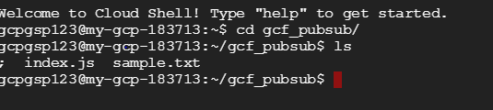

Create an index.js file in the gcf_pubsub directory with the following contents:

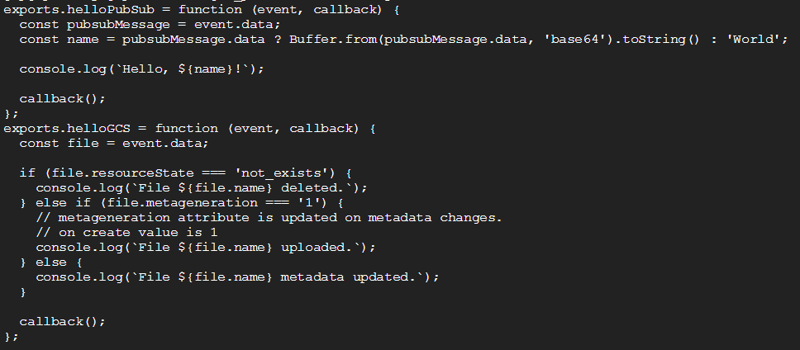

gcpgsp123@my-gcp-183713:~/gcf_pubsub$ cat index.js

exports.helloPubSub = function (event, callback) {

const pubsubMessage = event.data;

const name = pubsubMessage.data ? Buffer.from(pubsubMessage.data, 'base64').toString() : 'World';

console.log(`Hello, ${name}!`);

callback();

};

exports.helloGCS = function (event, callback) {

const file = event.data;

if (file.resourceState === 'not_exists') {

console.log(`File ${file.name} deleted.`);

} else if (file.metageneration === '1') {

// meta generation attribute is updated on metadata changes.

// on create value is 1

console.log(`File ${file.name} uploaded.`);

} else {

console.log(`File ${file.name} metadata updated.`);

}

callback();

};

The helloPubSub function is exported by the module and is executed when a message is published to the function's trigger topic.

## Deploying the function

To deploy the helloPubSub function with a Cloud Pub/Sub trigger, run the following command in the gcf_pubsub directory:

gcloud beta functions deploy helloPubSub --stage-bucket gcpgsp123 --trigger-topic filetopub

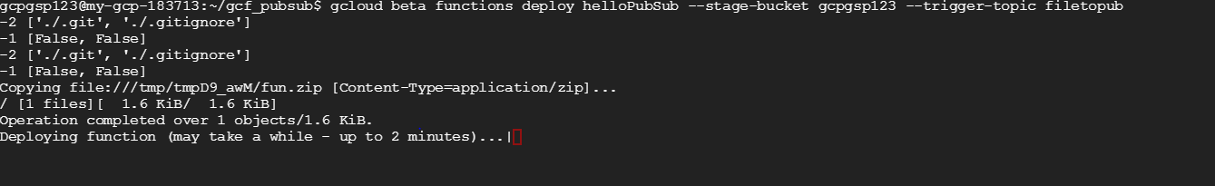

gcpgsp123@my-gcp-183713:~/gcf_pubsub$ gcloud beta functions deploy helloPubSub --stage-bucket gcpgsp123 --trigger-topic filetopub

-2 ['./.git', './.gitignore']

-1 [False, False]

-2 ['./.git', './.gitignore']

-1 [False, False]

Copying file:///tmp/tmpD9_awM/fun.zip [Content-Type=application/zip]...

/ [1 files][ 1.6 KiB/ 1.6 KiB]

Operation completed over 1 objects/1.6 KiB.

Deploying function (may take a while - up to 2 minutes)...done.

availableMemoryMb: 256

entryPoint: helloPubSub

eventTrigger:

eventType: providers/cloud.pubsub/eventTypes/topic.publish

failurePolicy: {}

resource: projects/my-gcp-183713/topics/filetopub

service: pubsub.googleapis.com

labels:

deployment-tool: cli-gcloud

latestOperation: operations/bXktZ2NwLTE4MzcxMy91cy1jZW50cmFsMS9oZWxsb1B1YlN1Yi83SzN2ejZsRWNXTQ

name: projects/my-gcp-183713/locations/us-central1/functions/helloPubSub

serviceAccount: my-gcp-183713@appspot.gserviceaccount.com

sourceArchiveUrl: gs://gcpgsp123/us-central1-helloPubSub-ygbzczblrsor.zip

status: READY

timeout: 60s

updateTime: '2017-10-27T11:52:31Z'

versionId: '15'

Note:

After deploying the function, All our local files will be copied as zip files into bucket.

i.e if you deploy the function from sdk then all your files in current directory will be copied as zip file into our storage location[Bucket].

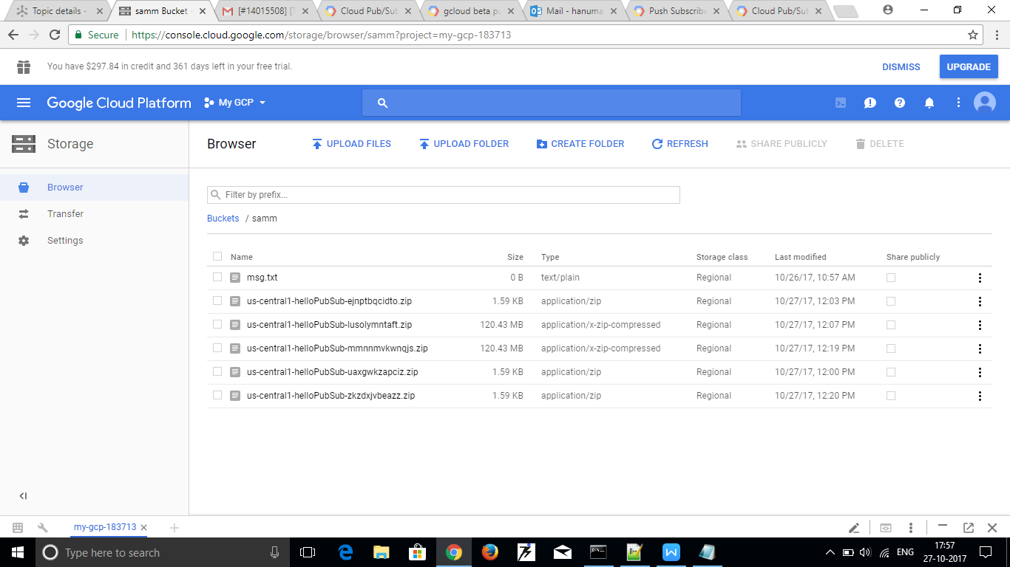

## **Triggering the function**

Publish a message to your Cloud Pub/Sub topic:

gcloud beta pubsub topics publish filetopub '{"name":"helloPubSub"}'

where [YOUR_TOPIC_NAME] is the name of your Cloud Pub/Sub topic, e.g. topic1

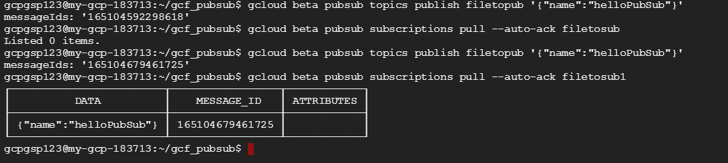

Watch the logs to be sure the executions have completed:

gcloud beta functions logs read --limit 50

gcpgsp123@my-gcp-183713:~/gcf_pubsub$ gcloud beta functions logs read --limit 50

LEVEL NAME EXECUTION_ID TIME_UTC LOG

I helloPubSub 164567814176532 2017-10-26 06:07:16.664 Hello, read.table(uri('gs://gcpgsp123/msg.txt'))!

D helloPubSub 164567814176532 2017-10-26 06:07:16.765 Function execution took 103 ms, finished with status: 'ok'

D helloPubSub 164568612097325 2017-10-26 06:07:42.727 Function execution started

I helloPubSub 164568612097325 2017-10-26 06:07:42.729 Hello, read.table('gs://gcpgsp123/msg.txt')!

D helloPubSub 164568612097325 2017-10-26 06:07:42.736 Function execution took 10 ms, finished with status: 'ok'

D helloPubSub 78186360164510 2017-10-26 06:10:47.601 Function execution started

I helloPubSub 78186360164510 2017-10-26 06:10:47.663 Hello, read.table('gs://gcpgsp123/msg.txt')!

D helloPubSub 78186360164510 2017-10-26 06:10:47.668 Function execution took 68 ms, finished with status: 'ok'

D helloPubSub 78186303960324 2017-10-26 06:11:19.431 Function execution started

I helloPubSub 78186303960324 2017-10-26 06:11:19.462 Hello, read.table('gs://gcpgsp123/msg.txt')!

D helloPubSub 78186303960324 2017-10-26 06:11:19.469 Function execution took 39 ms, finished with status: 'ok'

D helloGCS 164568620220517 2017-10-26 06:12:47.664 Function execution started

I helloGCS 164568620220517 2017-10-26 06:12:47.669 File undefined metadata updated.

D helloGCS 164568620220517 2017-10-26 06:12:47.766 Function execution took 148 ms, finished with status: 'ok'

D helloPubSub 78186314043924 2017-10-26 06:13:41.084 Function execution started

I helloPubSub 78186314043924 2017-10-26 06:13:41.163 Hello, read.csv(uri('gs://gcpgsp123/Emp.csv'))!

D helloPubSub 78186314043924 2017-10-26 06:13:41.166 Function execution took 83 ms, finished with status: 'ok'

D helloPubSub 78186682687425 2017-10-26 06:36:59.992 Function execution started

I helloPubSub 78186682687425 2017-10-26 06:37:00.062 Hello, xdg-open('gs://samm/msg.txt')!

D helloPubSub 78186682687425 2017-10-26 06:37:00.068 Function execution took 77 ms, finished with status: 'ok'

D helloPubSub 78186733024051 2017-10-26 06:41:01.292 Function execution started

I helloPubSub 78186733024051 2017-10-26 06:41:01.294 Hello, cat('gs://gcpgsp123/msg.txt')!

D helloPubSub 78186733024051 2017-10-26 06:41:01.299 Function execution took 7 ms, finished with status: 'ok'

D helloPubSub 164583080012047 2017-10-26 07:11:41.862 Function execution started

I helloPubSub 164583080012047 2017-10-26 07:11:41.866 Hello, fi.py!

D helloPubSub 164583080012047 2017-10-26 07:11:41.869 Function execution took 8 ms, finished with status: 'ok'

D helloPubSub 164588638601908 2017-10-26 07:27:15.716 Function execution started

I helloPubSub 164588638601908 2017-10-26 07:27:15.724 Hello, Hellooooooo!

D helloPubSub 164588638601908 2017-10-26 07:27:15.731 Function execution took 16 ms, finished with status: 'ok'

D helloPubSub 164583798200911 2017-10-26 07:27:35.157 Function execution started

I helloPubSub 164583798200911 2017-10-26 07:27:35.158 Hello, Hellooooooo!

D helloPubSub 164583798200911 2017-10-26 07:27:35.164 Function execution took 7 ms, finished with status: 'ok'

D helloPubSub 78193484882716 2017-10-26 12:22:16.257 Function execution started

I helloPubSub 78193484882716 2017-10-26 12:22:16.322 Hello, read.table('gs://gcpgsp123/Emp.csv')!

D helloPubSub 78193484882716 2017-10-26 12:22:16.339 Function execution took 83 ms, finished with status: 'ok'

D helloGCS 165051572414703 2017-10-27 08:12:39.849 Function execution started

I helloGCS 165051572414703 2017-10-27 08:12:39.918 File undefined metadata updated.

D helloGCS 165051572414703 2017-10-27 08:12:39.933 Function execution took 84 ms, finished with status: 'ok'

D helloGCS 165051319260490 2017-10-27 08:12:40.894 Function execution started

I helloGCS 165051319260490 2017-10-27 08:12:40.969 File undefined metadata updated.

D helloGCS 165051319260490 2017-10-27 08:12:40.974 Function execution took 81 ms, finished with status: 'ok'

D helloGCS 165052134913749 2017-10-27 08:14:10.584 Function execution started

I helloGCS 165052134913749 2017-10-27 08:14:10.664 File undefined metadata updated.

D helloGCS 165052134913749 2017-10-27 08:14:10.767 Function execution took 184 ms, finished with status: 'ok'

D helloGCS 165052267598456 2017-10-27 08:14:10.773 Function execution started

I helloGCS 165052267598456 2017-10-27 08:14:10.775 File undefined metadata updated.

D helloGCS 165052267598456 2017-10-27 08:14:10.778 Function execution took 6 ms, finished with status: 'ok'

D helloGCS 165102867205457 2017-10-27 11:52:31.347 Function execution started

I helloGCS 165102867205457 2017-10-27 11:52:31.414 File undefined metadata updated.

D helloGCS 165102867205457 2017-10-27 11:52:31.430 Function execution took 84 ms, finished with status: 'ok'

Note: There is no way to publish a file data through pubsub beta command

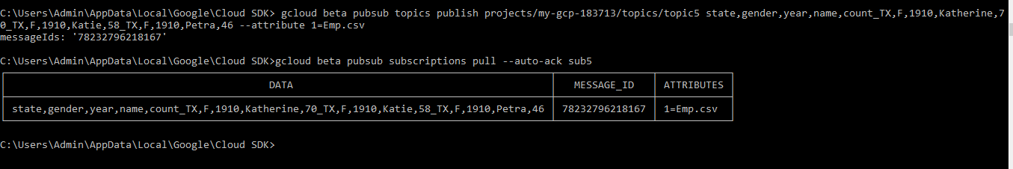

C:\Users\Admin\AppData\Local\Google\Cloud SDK> gcloud beta pubsub topics publish projects/my-gcp-183713/topics/topic5 state,gender,year,name,count_TX,F,1910,Katherine,70_TX,F,1910,Katie,58_TX,F,1910,Petra,46 --attribute 1=Emp.csv

messageIds: '78232796218167'

C:\Users\Admin\AppData\Local\Google\Cloud SDK>gcloud beta pubsub subscriptions pull --auto-ack sub5

┌───────────────────────────────────────────────────────────────────────────────────────────┬────────────────┬────────────┐

│ DATA │ MESSAGE_ID │ ATTRIBUTES │

├───────────────────────────────────────────────────────────────────────────────────────────┼────────────────┼────────────┤

│ state,gender,year,name,count_TX,F,1910,Katherine,70_TX,F,1910,Katie,58_TX,F,1910,Petra,46 │ 78232796218167 │ 1=Emp.csv │

└───────────────────────────────────────────────────────────────────────────────────────────┴────────────────┴────────────┘

